Grand Council Treaty #3 Presents:
Responding to Trauma & Grief
Workshop
Wyndham Garden Airport Hotel, Winnipeg MB
September 25th – 29th, 2023

FILLABLE FORM
NAME | Insert Name Here
COMMUNITY | Insert Community Here
ALLERGIES/DIETRY RESTRICTIONS: | Insert Info
EMAIL & PHONE | Insert Email Contact Here
DO YOU REQUIRE ACCOMMODATIONS?  (COVERED BY GCT3) | YES OR NO  Check in September 24th, 2023 and check out September 30th, 2023

Breakfast & lunch will be provided.
Mileage will be compensated to those who do not have the ability to claim through their own organizations

Please send completed forms to: damien.boyer@treaty3.ca

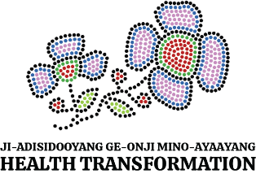

Miigwech!

