Grand Council Treaty #3:
Client Journey Mapping Kenora Region Engagement Session
NNADAP workers, MHA Front Line workers regional organizations, GCT #3 Allied partners.
Kenora, Ontario
January 31, February 1, February 2, 2023

FILLABLE FORM
NAME | Insert Name Here
COMMUNITY/ORGANIZATION | Insert Community Here
ALLERGIES/DIETRY RESTRICTIONS: | Insert Info
EMAIL & PHONE | Insert Email Contact Here
TRAVELLING FROM?

Lunch will be provided.

Please send completed forms to:
Nicole.Kejick@treaty3.ca
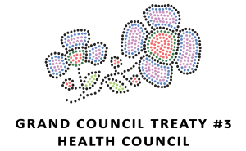

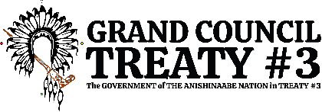
Miigwech!

