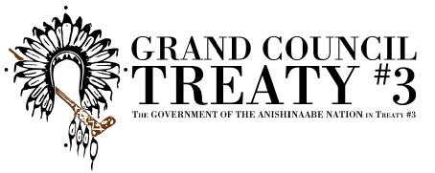
safeTALK: Suicide Alertness Training

About: safeTALK is a half-day training in suicide alertness. It helps participants recognize a person with thoughts of suicide and connect them with resources who can help them in choosing to live. Participants don't need any formal preparation to attend the training, anyone age 15 or older who wants to make a difference can learn the safeTALK steps.

Date: Saturday, April 9th 2022, 9:00AM - 2:00PM
Location: Minis Hall in Super 8 Hotel, Kenora
Facilitated by: Jessica Morton

Registration Form

FILLABLE REGISTRATION FORM
NAME
AGE
COMMUNITY
EMAIL
MAILING ADDRESS

Please send completed Registration Forms to:

corin.copenace@treaty3.ca

