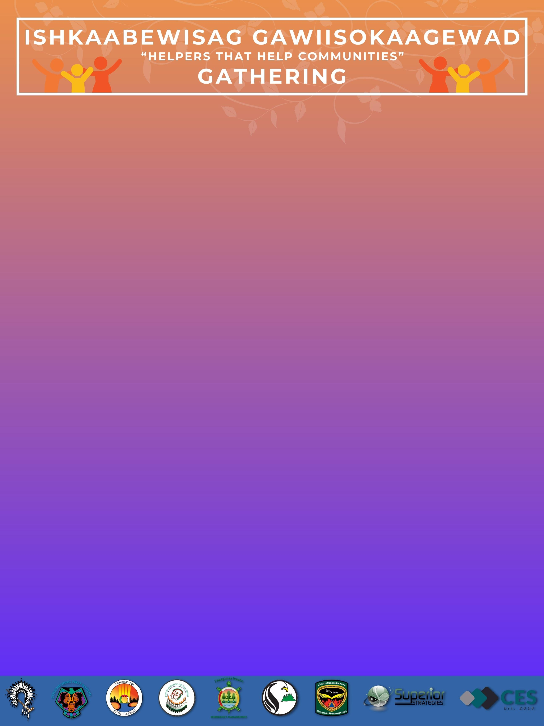

**Notes to organizers, special dietary needs:**

Click or tap here to enter text.

Send your completed form to: Kelli.Ducharme@treaty3.ca

**REGISTRATION FORM**

**In accordance with ONT Health regulations:**

**#1** Masks must be worn at all times, unless eating or drinking.

**#2** Social distancing is required.

**#3** PROOF of vaccinations to be provided.

50”

TV

This information will only be used to ensure we have ordered enough meals, that daily registration does not exceed 100 participants, and to reach you when you win a prize.

You will be eligible for all Daily Prizes when in attendance, and all Grand prizes.

**First Name:** Click or tap here to enter text. **Last Name:** Click or tap here to enter text.

**I am from Community:** Click or tap here to enter text. **Phone #:** Click or tap here to enter text.

**I wish to participate: In Person  Virtually**

**Please send me a Virtual link to my Email:** Click or tap here to enter text.

**I would like to participate every day for the entire week: YES  NO**

**If no, I will only be participating on: DAY 1**

**DAY 2**

**DAY 3**

**DAY 4**

**DAY 5**

**Please let us know which Day/Days you will be attending:**

Eventbrite Registration: **CLICK URL BELOW/HERE TO REGISTER**

<https://T3HelpersGathering2022.eventbrite.ca>