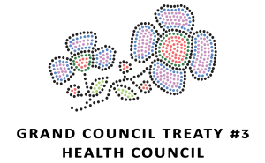

De-Escalation Potentially Violent Situations
About: For those who work in an environment where there is potential for violence, it is important to develop the skills needed to defuse dangerous situations. This workshop is designed to teach people to de-escalate potentially violent situations through assertiveness and interpersonal communication. The training will explore how anger and violence interplay, including opportunities for self-assessment of personal styles. Participants will develop a clear understanding of how to assess the potential for violence and respond with a diverse set of interpersonal tools and strategies designed to defuse potentially violent situations.

Registration Form
Date of Training: Oct 27th 2020 (9:00 AM - 4:00 PM Central Time)

Deadline for Registration is Friday, October 23rd 2020

FILLABLE REGISTRATION FORM
NAME
COMMUNITY
POSITION
EMAIL & PHONE

All costs covered by Grand Council Treaty #3 (Free)
Limited spots - must have access to Zoom

Please send completed Registration Forms to:
Corin Copenace - Health Transformation Admin Assistant at corin.copenace@treaty3.ca

