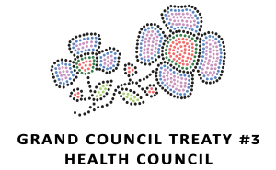
GRAND COUNCIL TREATY #3 HEALTH DEPARTMENT PRESENTS:
PHOTOVOICE CONTEST
THEME: Treaty #3 Youth and COVID-19
Examples of photos that can be taken:
How are you connecting with our friends and family with physical distancing?
How are you staying positive during COVID-19?
What are the signs of spring you are seeing?
Who is Eligible?
Treaty #3 Youth ages 12-29 years old
Please note there will be two age categories for draws ages 12-18 and ages 19-29
Photovoice Contest Rules:
Youth may submit as many photos as they would like but are only eligible for their name to be entered into the draw once. All photos MUST be appropriate, no nudity, or offense scenes or language. Please ensure you ask permission to take a photo of someone else. Each photo must be accompanied by a brief description detailing the photo. Be CREATIVE, have fun and practise safe social distancing!
Registration Form
Deadline for Registration is Wednesday, April 15th, 2020
Draw will take place LIVE on GCT3 Facebook page on April 16th, 2020 @ 12pm
FILLABLE REGISTRATION FORM
NAME
COMMUNITY
AGE
Can we upload your photo and photo description to our Grand Council Treaty #3 Facebook Page?
YES NO
Photo Description:
_________________________________________________________________________________________________________________________________________________________________________________________________________________________________________________________________________________________________________________________________________________________________________________________________________________________________________________________________________________________________

PLEASE SEND PHOTO AND COMPLETED FORM TO:
Tassanee Weese – Mental Health Policy Analyst at mhpa@treaty3.ca
If you have any questions, please contact Tassanee at 807-464-6517

Miigwech!

