Communicable Disease Emergency Plan
for First Nations and Inuit Communities South of 60
Please note: The writing that is highlighted in blue are suggestions and should be reviewed and completed as required.
You may remove sections if they are not relevant to your community’s role or responsibilities.

Table of Contents
SECTION 1: OVERVIEW
1.1 Introduction………………………………………………………………………………………………………………………3
1.2 Purpose and Scope………………………………………………………………………………………………………,……3
1.3 Plan Review/Maintenance/Distribution……………………………………………………………………,………4
1.4 Training and Exercises ………………………………………………………………………………………………,………4

1.5 Mutual Aid Agreements…………………………………………………………………………………..………………..5
1.6 Context for a Communicable Disease Emergency…………………………………………….………………..5
1.7 Roles and Responsibilities………………………………………………………………….………………………………6
1.7.1 Community Level Responsibilities……………………………………………………………………………………..6
1.7.2 Provincial Level Responsibilities………………………………………………………………………………………..6
1.7.3 Federal Level Responsibilities……………………………………………………………………………………………6

SECTION 2: CONCEPT OF OPERATIONS
  - Activation of the Communicable Disease Emergency /Pandemic Plan …………………………….….7

  - Deactivation of the Communicable Disease Emergency /Pandemic Plan……………………………..7

  - Emergency Operations Centre………………………………………………………………………..…………………..7
2.4 Key Components of Communicable Disease Emergency Planning…….………………8
2.4.1 Communications…………………………………………………………………………………………………………………8
2.4.2 Surveillance………………………………………………………………………………………………………………………..9
2.4.3 Public Health Measures …………………………..………………………………………………….……………………..9

2.4.4 Infection, Prevention and Control Measures……………………………………………………………….…….12
2.4.5 Continuity of Health Operations…………………………………………..……………………………………………13
2.4.6 Laboratory Services…………………………………………………………………………………………………………..14

2.4.7 Antiviral Medication …………………………………………………………………………………………………………14
2.4.8 Vaccines……………………………………………………………………………………………………………………………15
2.4.9 Ethical Considerations………………………………………………………………………………………………………16
SECTION 3: RECOVERY AND EVALUATING THE COMMUNICABLE DISEASE EMERGENCY RESPONSE
3.1 Debriefing/s …………………………………………………………..………………………………………………………..16

3.2 Recovery………….……………………………………………………………………………………………………………….16
SECTION 4: APPROVAL of PANDEMIC INFLUENZA PLAN ……….……...……………………………………………….…17
SECTION 5: APPENDICES
Appendix A – Volunteer Contact Information List…………………………………………………………………18

Appendix B – How to Handrub……………………………………………………………………………………………..19

Appendix C – How to Handwash…………………………………………………………………………………..………20

Appendix D - Contact Information of Internal/External Government Departments and
Community Partners……………………………………………………………………………………….21

SECTION 6: GLOSSARY………………………………………………………………………………………………………………………22
SECTION 1: OVERVIEW
1.1 Introduction
INSERT COMMUNITY NAME acknowledges its role and responsibility in the event of a communicable disease emergency (CDE) such as pandemic influenza. INSERT COMMUNITY NAME will work closely with key partners to implement an integrated, comprehensive, and coordinated plan in the event of a CDE.

Partners
Local | List local partners
Regional | List regional partners
Provincial | List provincial partners
Federal | List federal partners

1.2 Purpose and Scope
The purpose of this plan is to minimize the impact of the CDE by helping the community
  - Prepare for, respond to, and recover from a CDE
  - Ensure a coordinated response to a CDE
  - Preserve the health and well-being of community members and staff
  - Sustain essential operations.
The Plan includes:

- Roles and responsibilities of XX community, and regional/ provincial /federal health partners;
- The decision-making process to activate and deactivate the Plan;
- A process for ethical decision-making during an emergency;
- Key elements of communicable disease emergency preparedness and response.

1.3 Plan Review/Maintenance/Distribution
The following emergency management plans/agreements were reviewed to ensure consistency with the communicable disease emergency plan (add/ remove as relevant).
Local | All-hazards emergency plan  Business continuity plan  Neighbouring community agreements  Other (specify)
Provincial | All-hazards emergency plan  Public Health Act  Emergency management plan  Provincial emergency management legislation  Other (specify)
Federal | Federal emergency management legislation  Other (specify)

INSERT TITLE OF PERSON is responsible for developing the community CDE plan. The plan will be reviewed annually by COMMUNITY HEALTH COMMITTEE/ COMMUNITY EMERGENCY COMMITTEE/ INSERT TITLE OF PERSON. Changes to the plan will be made as required. The revised plan will be submitted to INSERT TITLE OF PERSON for administrative approval. After the plan is revised and approved it will be circulated/ recirculated amongst all staff and community partners.
1.4 Training and Exercises

Training and exercises are essential to emergency preparedness because they help individuals understand their role in the event of an emergency/disaster event. INSERT COMMUNITY NAME supports employee training that includes but is not limited to the following:

- Basic Emergency Management
- Incident Command System
- Emergency Operations Centre
- Crisis Communications
- Stress management
- Promoting community resiliency

Exercises help communities prepare for emergencies. They provide an opportunity to develop relationships with community partners/stakeholders, assess operational readiness for an emergency, resource requirements and role clarity. INSERT NAME OF COMMUNITY will hold communicable disease emergency preparedness exercises every INSERT # OF YEARS.

The date of the next exercise is INSERT DATE.

1.5 Mutual Aid Agreements
Mutual aid agreements are written agreements with nearby communities to assist during an emergency. These agreements could include the type of support needed (for example, supplies, staff, or knowledge). It could also indicate how the community requests support, and who the request should come from.

INSERT COMMUNITY NAME has mutual aid agreements with the following communities. The agreements are attached to this Plan. INSERT TITLE OF PERSON updates the agreements every INSERT NUMBER OF YEARS.

Community Name | Last Update (Year) | Next Update Due (Year)

1.6 Context for a Communicable Disease Emergency
Communicable diseases spread from one person to another. They can also spread from an animal to a human. Small germs cause communicable diseases. Communicable diseases can spread in many ways. They may spread by:
  - Contact with:
    - Coughing, sneezing, and saliva (for example, flu, chicken pox, TB)
    - Body fluids like blood, semen, vomit, and diarrhea (for example, food poisoning, HIV)
  - Indirectly by:
    - Unwashed hands
    - Unclean surfaces
    - Unclean food or water
    - Bites from insects or animals
Some communicable diseases spread easily between people. This can become an emergency when many people get the disease.
A communicable disease emergency is a current and serious situation. It affects a community for a short time. The community may not have the resources to care for everyone. They may need help from other levels of government.

1.7 Responsibilities
Indicate the responsibilities of different levels of government during a CDE. The template provides suggestions, but it is not comprehensive. Please review relevant agreements, policies, guidelines, and legislation, including outbreak management plans and public health legislation. Discuss potential responsibilities with your partners using the topic areas below and add, remove, or adapt responsibilities as needed.

1.7.1 Community Level Responsibilities
INSERT COMMUNITY NAME is responsible to:

- Develop, test and update the communicable disease emergency plan in collaboration with partners and stakeholders and as part of their community health planning process.
- Support employee preparation for emergencies, including through training and exercises.
- Coordinate with health officials at different levels of government, as well as municipal and community partners.
- The Health Director or Nurse-in-Charge is responsible for the planning resources.
- Review local and provincial outbreak management plans to ensure alignment.
- Familiarize themselves with provincial emergency management and public health legislation.
- Other (specify)

1.7.2 Provincial Level Responsibilities
PROVINCE is responsible to:
These are topics you may want to discuss with your provincial counterpart.
- Communications to and from community
- Access to provincial stockpiles (for example, vaccines, antivirals, and personal protective equipment)
- Support to communities during an emergency (for example, staffing surge capacity, funding)
1.7.3 Federal Level Responsibilities
Public Health Agency of Canada (PHAC) is responsible to:
- Integrate First Nations and Inuit communities’ considerations and realities into federal documents.
- Communication
- Coordination
- Federal vaccine, antiviral, and personal protective equipment stockpiles
- Other (specify)
Indigenous Services Canada (ISC) is responsible to:
- Access to health services
- Prevention, preparation, and response to health emergencies
- Other (specify)

SECTION 2: CONCEPT OF OPERATIONS
2.1 Activation of the Communicable Disease Emergency /Pandemic Plan
Explain HOW and WHEN the plan will be activated, and by WHO (an example is provided below).
INSERT TITLE OF PERSON or designate may activate appropriate components of the communicable disease emergency plan based on situational requirements. When the plan or any of its components are activated, the INSERT TITLE OF PERSON or designate will assume the lead role in notifying the Chief and Council, the manager of the health facility (who in turn will notify Provincial MOH), and the Regional Office of Indigenous Services Canada of the change in the situation and the implications related to same.

2.2 Deactivation of the Communicable Disease Emergency /Pandemic Plan
Explain HOW and WHEN the plan will be deactivated, and by WHO (an example is provided below).
The INSERT TITLE OF PERSON will deactivate the Communicable Disease Emergency Plan/or components of it or have key people meet on an ad-hoc basis when:
- The public health emergency is declared over by Provincial MOH, and/or
- Local impact has diminished to a level where normal services may be resumed.

2.3 Emergency Operations Centre Location
An emergency operations centre is a central command centre. It is from where the emergency is managed. It helps ensure the continuity of operations. This location must have a computer, telephone and fax machine.
Indicate location of Emergency Operations Centre
2.4 Key Components of Communicable Disease Emergency Planning
The following provides an overview of the major components of CDE preparedness and response.

2.4.1 Communications
Communication of information and advice is often the first public health intervention during an emergency. Providing clear and consistent information about the disease, who it affects, how it spreads and ways to reduce risk is an effective way to help reduce the spread of infection before other interventions like vaccines are available. Communications should follow the principles of honesty, openness, and cultural sensitivity to build and maintain public trust. Communication should be accurate and consistent

INSERT TITLE OF COMMUNITY will share communications via (check those that apply and add as necessary):
□ social media (Facebook, Twitter, etc)
□ radio announcements
□ media interviews
□ press releases
□ mail-out notifications (ie. via email)

INSERT TITLE OF COMMUNITY will share communications in INSERT LANGUAGES.

INSERT TITLE OF PERSON or their delegate is responsible to communicate on health related matters with community members, health facility staff, and other local/ provincial/ federal partners and stakeholders.

INSERT TITLE OF PERSON or their delegate is responsible to communicate on non-health related matters related to the emergency with community members, health facility staff, and other local/ provincial/ federal partners and stakeholders.

INSERT TITLE OF PERSON will receive all media inquiries during the communicable disease emergency and will ensure that those responsible for communication are designated speakers.

Key items to include in communications to the public are:
- Local, provincial, national, and international situation
- Level of risk
- Public health response
- Signs and symptoms
- Recommendations including prevention measures, how to care for an ill family member, when to seek care, and when to stay home.

    - Surveillance
Surveillance between pandemics serves as a warning system. Surveillance during CDEs provides decision makers with the information they need for an effective response.
The purpose of surveillance during a communicable disease emergency is to provide data on the current status of the infectious disease (e.g., clinical cases, hospitalizations and deaths; severe clinical syndromes and associated risk groups; and demands on the health system); to detect the emergence of new cases in a timely fashion and to monitor the spread and impact on communities; and to rapidly prioritize and maximize an efficient response.

XXX or their delegate is responsible to report notifiable diseases to local/ provincial public health authorities. Please consider reporting this information to FNIHB Regional Office as well. Local/ Provincial public health epidemiologists will analyze the data.
Responsibilities will be assigned to the community Public Health Nurse who will report all surveillance data to the Communicable Disease Control Nurse. This Regional Nurse will then report all gathered surveillance information to FNIHB, Region Department and other stakeholders, as required. Surveillance information may be shared with the Community, as necessary.
    - Public Health Measures

Public health measures are non-pharmaceutical interventions to help prevent, control, or mitigate communicable diseases. These measures help reduce transmission of the disease to reduce the size of the outbreak, the number of severely ill cases and deaths, and reduce the burden on the health care system. Public health measures range from actions taken by individuals (e.g., hand hygiene, self-isolation) to actions taken in community settings and workplaces (e.g., increased cleaning of common surfaces, social distancing) to those that require extensive community preparation (e.g., pro-active school closures).

Provincial and federal public health authorities will provide advice on public health measures as the emergency develops. The provincial or federal CMOH may enforce some public health measures as per their authority under the INSERT NAME OF RELEVANT PUBLIC HEALTH LEGISLATION. INSERT TITLE OF PERSON is responsible to ensure that local public health measures align with advice given by local, provincial, and federal public health authorities. Direction and support will be provided on Public Health Measures, as required by INSERT NAME OF ORGANIZATION.

The following outline key Public Health Measures that INSERT NAME OF ORGANIZATION may implement during a Pandemic Influenza event.

  - Individual level public health measures may include (This is a partial list. Add/ revise/ remove as relevant for your community and the CDE. Consider helpful and harmful local/ traditional practices.):

Measure | Risk/ Impact | Mitigation Strategy | Trigger to recommend this measure
Clean hands with soap and water/ hand sanitizer often | Accessibility of clean water and soap. Accessibility of hand sanitizer, risks of human consumption of hand sanitizer | Community handwashing stations. | Ongoing promotion. Increased promotion during flu season and when there is known potential for CDE (ie pandemic declaration)
Respiratory etiquette | None | None | Ongoing promotion. Increased promotion during flu season and when there is known potential for CDE (ie pandemic declaration)
Don’t share personal items | Households may not have enough for each individual | Consider surge supply during emergencies.
Mandatory screening/ treatment | Limits on personal freedoms; relationship strain between community and health services | Build relationship with community before emergencies; clear communication.
Recommend / Do not recommend (INSERT local/ traditional practice) | Local and traditional practices can provide significant benefits to mental and social health.
Self-isolate in home | Overcrowded housing; isolation | Facilitate access to necessities such as groceries.
Vaccines/ pre-exposure prophylaxis with anti-virals | Possible limited supply; cost-benefit analysis

- Community level public health measures may include (This is a partial list. Add/ revise/ remove as relevant for your community and the CDE):

Measure | Risk/ Impact | Mitigation Strategy | Trigger to start implementing this measure
Close schools, daycares, community centres, schools | Loss of community and social support, possibly access to food or safe spaces | Additional food bank hours or allowances; phone support to families
Cancel or modify community programming, sporting events | Loss of community and social support, possibly access to food or safe spaces
Implement increased cleaning of public spaces | Cost and human resources
Public awareness campaigns | May not address relevant issues, may not be culturally safe and responsive | Local input into campaigns; engage trusted community members and experts
Isolation/ Quarantine/ travel restrictions | Limits on personal freedoms; social isolation; relationship strain between community and health services | Facilitate access to necessities, including social contact. | Normally recommended by local/ provincial/ federal health authorities under strict conditions
Alternative working strategies (ie. flexible hours or work locations) | Access to internet for telework

    - Infection, Prevention and Control Measures

Infection Prevention and Control (IPC) is key to preventing the spread of communicable diseases. Personal Protective Equipment (PPE) and IPC training are essential. IPC and Occupational Health and Safety (OHS) programs should work together to prevent staff, patient, and visitor exposure to communicable diseases during the provision of health care. See Appendix B and C for World Health Organization hand washing/rubbing steps.

The following elements of IPC and OHS programs are present in local health facilities to prepare and respond to communicable disease emergencies. PLEASE IDENTIFY WHICH COMPONENTS ARE PRESENT IN YOUR COMMUNITY

IPC and OHS professionals are staffed/contracted to the health care organization to conduct education and training for front line staff.
Comprehensive IPC and OHS education and training on communicable diseases is provided yearly to health facility staff. A plan is in place to provide training if and when an emergency occurs.
An organizational risk assessment has identified administrative controls and personal protective equipment (PPE) to protect patients, health care workers and visitors in health facilities.
Organizational policies and procedures for IPC and OHS exist, including:
- Point-of-care risk assessments
- PPE and fit-testing
- Housekeeping
- Surveillance for health facility associated infections
- Staff and patient vaccination policies
- Source control
- Facility outbreak management protocols that align with provincial outbreak management plans
- PPE supplies
- Access to provincial and federal stockpiles (PPE, vaccines, and antivirals)

2.4.5 Continuity of Health Operations
A communicable disease emergency usually exceeds the capacity of the health system, particularly in remote and isolated communities. Communities will face an increased demand for health services. There may be a shortage of health professionals due to personal or family sickness. Family, friends, and volunteers may need to provide care to sick family members. Non-urgent health services may need to be postponed.

TITLE OF PERSON is responsible to inform CHIEF/ COUNCIL/ HEALTH COMMITTEE/ OTHER (IDENTIFY) if the health facility’s capacity is exceeded and non-urgent health services are postponed. If health and public health services are available outside of the community, TITLE OF PERSON is responsible to inform community members when, where, and what services may be accessed.

In a communicable disease emergency, the following strategies may be used to increase the capacity of the health facility. INDICATE WHICH STRATEGIES THE COMMUNITY HAS IN PLACE, INCLUDING “CONSIDERATIONS”
□ Additional staff (Consider: professional licensing, job descriptions, delegation authority, recruitment, agreements with neighbouring communities, agencies, or provincial/ federal government, funding)
□ Additional supplies (Consider: funding, sourcing, contracts)
□ Additional space (Consider: locally, agreements with neighbouring communities, medevacs)
□ Self-assessment for health care providers planning to return to the workplace after illness
□ Prioritization of health services

In the event of a communicable disease emergency, health services will be prioritized as follows:
- INSERT PRIORITIZED LIST OF HEALTH SERVICES

In the event of a communicable disease emergency, community services such will be prioritized as follows:

- INSERT PRIORITIZED LIST OF COMMUNITY SERVICES

Supplemental mental health and social support for community members and health staff may be required during and after a communicable disease emergency. The following partners and organizations may be contacted for culturally safe mental health and social support during a communicable disease emergency:

- LIST ORGANIZATIONS AND PARTNERS

2.4.6 Laboratory Services

Laboratory-based surveillance is an important part of monitoring communicable disease activity.
Rapid identification of a communicable disease and timely tracking of disease activity throughout the duration of the emergency are critical to a successful response. In the early stages of a pandemic, laboratory services may also provide guidance on appropriate clinical treatment.

The purpose of laboratory services during a pandemic is to:

- Support public health surveillance by confirming and reporting positive results;
- Facilitate clinical management by distinguishing patients infected with the communicable disease from those with other diseases;
- Monitor circulating viruses for antiviral resistance and characteristics; and
- Assess vaccine match and support vaccine effectiveness studies.

TITLE OF PERSON is responsible to communicate with any relevant laboratories and ensure all relevant health care providers are aware of any new laboratory guidelines and protocols.
Positive test results will be reported as per local and provincial public health requirements. Please consider reporting to FNIHB regional office as well.

2.4.7 Antiviral Medication

Antiviral medication can be used to treat viruses (such as influenza) or to prevent viruses in exposed persons (prophylaxis). Antiviral medications are the only specific anti-influenza intervention available that can be used from the start of the pandemic, when vaccine is not yet available.

TITLE OF PERSON is responsible to collaborate with provincial/ federal authorities to ensure an adequate supply of antiviral medication for the community. Provincial clinical guidelines for administration and reporting will be followed including side effects, adverse events, and unused medication. Please consider reporting this information to FNIHB Regional Office as well.
TITLE OF PERSON maintains a list of the community’s most medically vulnerable residents. This list is located XXX. Individuals who are unable to visit the health facility will receive home visits for vaccination. These home visits will be conducted as per the local health facility guidelines.
TITLE OF PERSON will communicate with residents regarding antiviral medication prioritization and availability.

2.4.8 Vaccines
Immunization, especially of susceptible individuals is the most effective way to prevent disease and death from influenza. High seasonal influenza vaccine coverage rates are a good predictor of pandemic vaccine coverage rates. Vaccination during influenza pandemics can build upon a strong seasonal influenza immunization program. The overall impact of the pandemic vaccine will depend on vaccine efficacy and uptake, as well as the timing of vaccine availability in relation to pandemic activity.

This component aims to provide a safe and effective vaccine to residents of INSERT COMMUNITY NAME as soon as possible; to allocate, distribute and administer vaccines as efficiently and fairly as possible; and to monitor the safety and effectiveness of pandemic vaccine.

XXX is responsible to collaborate with provincial authorities to ensure an adequate supply of pandemic influenza vaccine for the community. All community health nurses will obtain and maintain their immunization competency. Provincial vaccination procedures will be followed including reporting administration, side effects, adverse events, and unused vaccine. Please consider reporting this information to FNIHB Regional Office as well.
Site-specific vaccine storage protocols exist and will be followed. In the event that the vaccine provided exceeds the storage capacity of the health centre’s vaccine fridge, DESCRIBE HOW THE PROVINCE WILL SUPPORT THE COMMUNITY IN FUNDING VACCINES OR ADMINISTRATIVE SUPPLIES.
TITLE OF PERSON maintains a list of the community’s most medically vulnerable residents. This list is located XXX. Individuals who are unable to visit vaccination clinics will receive home visits for vaccination. These home visits will be conducted as per the local health facility guidelines.
TITLE OF PERSON will communicate with residents regarding vaccine priority requirements, clinic locations and times.
TITLE OF PERSON is responsible for the logistics of setting up a vaccination clinic, including location, volunteers, and scheduling.
Potential clinic locations are: LIST POTENTIAL CLINIC LOCATIONS
Potential volunteers are listed in Appendix A.

2.4.9 Ethical Considerations

Communicable disease emergencies often present ethical dilemmas. Decisions may be required on when to provide or withhold vaccines, antivirals, and/ or treatment, among other things.

In the event that ethical dilemmas requiring a decision arise, relevant members of the communicable disease emergency team have an agreement to work with ethicists at INSERT TITLE OF ORGANIZATION to resolve the dilemma. INSERT ANY CRITERIA FOR WHO SHOULD WORK WITH ETHICISTS (IE. AT LEAST ONE PERMANENT COMMUNITY MEMBER, A BAND COUNCILLOR, HEALTH STAFF).

SECTION 3: RECOVERY AND EVALUATING THE COMMUNICABLE DISEASE EMERGENCY RESPONSE

3.1 Debriefing/s

Processes, activities, and decisions made during the CDE response should be documented for future reference. The response should be evaluated to see what went well, what could be done differently, and what the outcome was. This evaluation helps ensure that lessons learned from the real-life event are captured and remain available to inform CDE plan revisions.

Debriefings are recommended following an emergency/disaster event, particularly after an evacuation has been ordered. All of the following types of debriefs are recommended:
- Quick tactical debriefing with CDE RESPONSE TEAM/ OUTBREAK TEAM (what went well, what didn’t, how to improve);
- Operational debriefing, including community partners/stakeholders (Appendix D);
- Questionnaire (to volunteers, community partners/stakeholders, owners of building sites used, etc.) in order to identify gaps and future considerations for improvement; Development of an After-Action Report, a financial report, and a report to INSERT TITLES OF PEOPLE WHO SHOULD RECEIVE REPORT. Results of the report should also be shared with community members.

TITLE OF PERSON or their delegate is responsible to organize the debriefings. TITLE OF PERSON or their delegate is responsible to ensure the lessons learned are incorporated into the communicable disease emergency plan.
3.2 Recovery

After the emergency is over, INSERT COMMUNITY NAME will recognize the losses, celebrate the community’s resilience, and begin the healing process. The following events will be considered after the emergency has been declared over.

- INSERT LIST OF IDEAS TO PROMOTE COMMUNITY RECOVERY AND BUILD RESILIENCE

SECTION 4: APPROVAL of PANDEMIC INFLUENZA PLAN

Approved by:  Health Director | Date:
Approved by:  General Manager | Date:
Approved by:  Chief & Council | Date:

SECTION 5: APPENDICES
Appendix A
Volunteer Contact Information List

Name | Phone number | Email

Appendix B

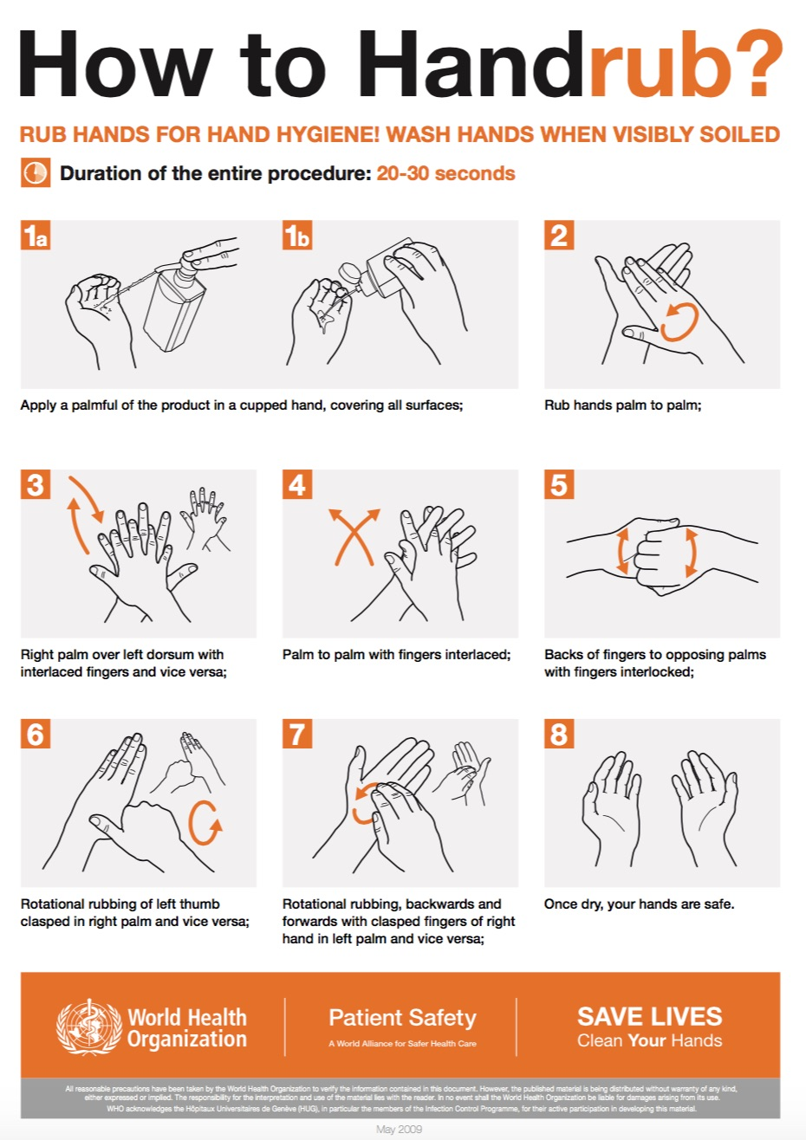

Appendix C
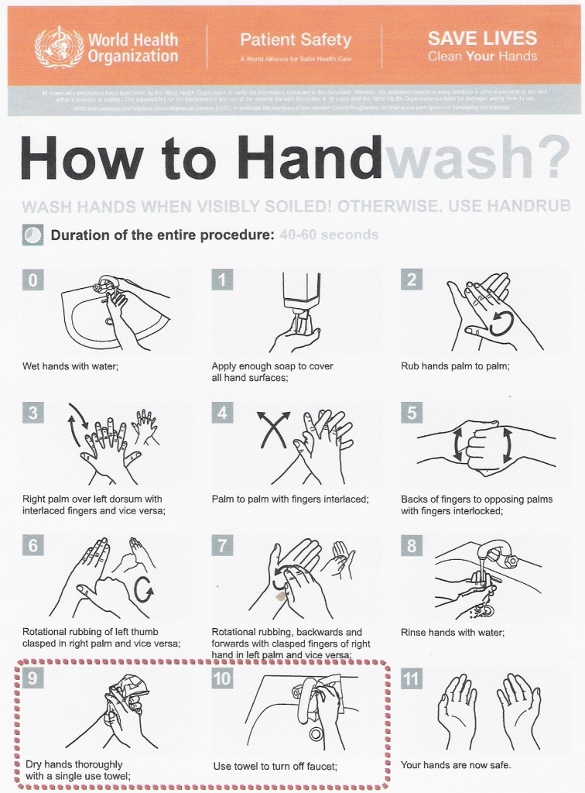

Appendix D

Contact Information of Internal/External Government Departments and Community Partners
Title of person | Name | Phone number | Email

SECTION 6: GLOSSARY
Activation - The implementation of procedures, activities, and emergency plans in response to an emergency event, Universal Emergency Code, or disaster.

All-Hazards - Describing an incident, natural or manmade, that warrants action to protect life, property, environment, public health or safety, and minimize disruptions of government, social, or economic activities.

Business Continuity - An ongoing process supported by the Centers manager/s and funded to ensure that the necessary steps are taken to identify the impact of potential losses, maintain viable recovery strategies, recovery plans, and continuity of services.

Business Continuity Plan - A collection of procedures and information which is developed compiled and maintained in readiness for use in the event of an emergency or disaster.

Communicable Disease Emergency - Communicable diseases spread from one person to another. They can also spread from an animal to a human. Small germs cause communicable disease. Communicable diseases can spread many ways. They may spread by:
  - Contact with:
    - Coughing, sneezing, and saliva (for example, flu, chicken pox, TB)
    - Body fluids like blood, semen, vomit, and diarrhea (for example, food poisoning, HIV)
  - Indirectly by:
    - Unwashed hand
    - Unclean surface
    - Unclean food or water
    - Bites from insects or animals
Some communicable diseases spread easily between people. This can become an emergency when many people get the disease.
A communicable disease emergency is a current and serious situation. It affects a community for a short time. The community may not have the resources to care for everyone. They may need to ask for help from other levels of government.

Disaster - An event that results in serious harm to the safety, health or welfare of people or in widespread damage to property

Emergency - A present or imminent event outside the scope of normal operations that requires prompt co-ordination of resources to protect the safety, health and welfare of people and to limit damage to property and the environment.

Emergency Management - An ongoing process to prepare for, mitigate against, respond to and recover from an incident that threatens life, property, operations, or the environment.

Incident -A relatively common situation requiring a specific response. It is generally handled by standard operating procedures and the agency/region has sufficient resources to respond.

Incident Command System (ICS) - A standardized organizational system that guides emergency response operations within MFN. The ICS assists in the comprehensive coordination and management of resources. The ICS is used within the Emergency Operations Centre (EOC).

Preparedness - Activities, programs, and systems developed and implemented prior to a disaster/emergency event that are used to support and enhance mitigation of, response to, and recovery from disasters/emergencies.

Recovery -Activities and programs designed to return conditions to a level that is acceptable to the entity.

Response - Activities designed to address the immediate and short-term effects of the disaster/emergency event.

Resilience - The capacity of a system, community or society potentially exposed to hazards to adapt, by resisting or changing in order to reach and maintain an acceptable level of functioning and structure. This is determined by the degree to which the social system is capable of organizing itself to increase this capacity for learning from past disasters for better future protection and to improve risk reduction measures.

Risk - The likelihood of an event occurring multiplied by the consequence of that event, were it to occur. Risk = Likelihood x Consequence.

Stakeholder - An individual/s, agency (RCMP, Central Health), local municipality, department (fire rescue, Fire Emergency Services-NL) who has an interest in or investment in a community and who is impacted by and cares about how it turns out.

