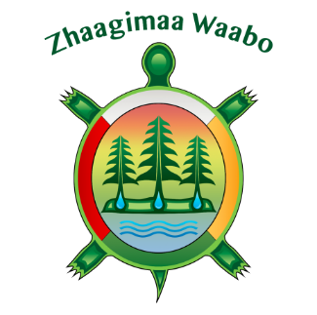
Grand Council Treaty 3
REGISTRATION FORM
Information
Environmental Science Fair
January 28th 29th, 2020
Seven Generations Education Institute
9:00 AM – 4:00 PM

Those recommended to attend:
Treaty 3 First Nation students in grade 7 to 12 are highly encouraged to attend.
REGISTRATION FORM
Name:
School:
Community:
Program/Title:
Phone/Cell:
Email:
Please indicate if you are a driver:
Special Dietary/Allergies:

Do you require hotel accommodation: YES NO
Nights required: January 27th 2020 / January 28th 2020 / January 29th 2020
*If you require hotel accommodations, we will send you the confirmation # and other details. Please note, if you need to cancel accommodations, please contact the accommodation provider 24 hours before check-in time, otherwise your community may be responsible for costs incurred.
Registration Deadline: January 13th 2020 at 4:30 pm.
***GCT#3 WILL PROVIDE TRAVEL, MILEAGE, MEALS AND INCIDENTALS FOR UP TO 6 YOUTH WHO ARE IN HIGHSCHOOL AND THEIR CHAPERONES (2)***
For more information please contact: Geneva: Geneva.kejick@treaty3.ca (807) 548-4214
Please send completed forms to:
GCT3 Fax: (807) 548-5041, or by email to geneva.kejick@treaty3.ca

