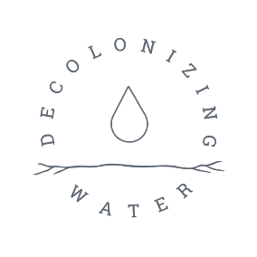
Grand Council Treaty #3

REGISTRATION FORM

NATIONAL NIBI GATHERING
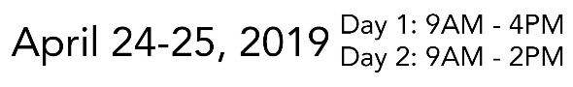

7 Generations Education Institute
Kenora, ON

REGISTRATION FORM
Name:
Community:
Position in Community:
Phone:
Email:
Please indicate if you are a driver: | We encourage carpooling for this  event to help reduce gas emissions
Special
Dietary / Allergies:

Will you be attending: All Days or Day 1 Only Day 2 Only
Do you require Hotel Accommodations? Yes or No

**If you require hotel accommodations, we will send you the confirmation # and other details.
Please note, if you need to cancel accommodations, please contact the hotel 24 hours before check-in time, otherwise your community may be responsible for reimbursement to GCT#3 for missed accommodations**

Registration Deadline: April 5th, 2019 at 4:30 pm
GCT#3 & Decolonizing Water will provide travel and/or accommodation for only
1 Women, 1 Youth and 1 Elder per Treaty #3 community.

Breakfast and Lunch provided each day.

For more information please contact:
Lucas King: water@treaty3.ca

