Grand Council Treaty #3:
Compassionate Connection with Families impacted by Substance Abuse

Yellowbird Resorts
Sioux Narrows, ON
Friday, August 19th 2022
8:30AM – 3PM

Breakfast & Lunch provided.
Stipend provided to participants.

Registration Deadline August 12th/22

FILLABLE FORM
NAME | Insert Name Here
NAME OF COMMUNITY | Insert Community Here
ALLERGIES/DIETRY RESTRICTIONS: | Insert Info
EMAIL & PHONE | Insert Email Contact Here

Lunch will be provided.
*All attendees must be double vaccinated*

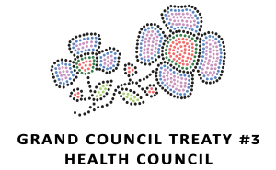
Please send completed forms to:
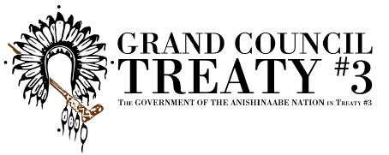
Breeze Boucha – Breeze.Boucha@treaty3.ca

Miigwech!

