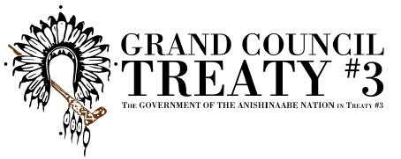
A journey around the medicine wheel: holistic health & wellness:
12 virtual presentation series with
Earl Lambert

Please note that the following technology will be required to participate:
- High speed internet
- The ability to download and use Zoom

Registration Form

FILLABLE REGISTRATION FORM
NAME
Age
COMMUNITY
ZOOM USERNAME
EMAIL/PHONE

Please send completed registration forms to: Johnpaul.george@treaty3.ca

