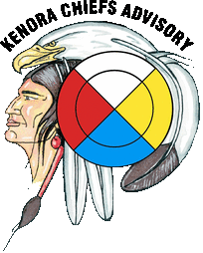
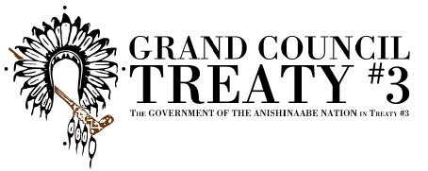

Anishinaabe Nation in Treaty #3 Traditional Knowledge and Healing Gathering
About: ceremonial dances, sweatlodges and workshops to revitalize and provide a learning opportunity for our traditional practices. The gathering will provide an opportunity to bring communities; clans and families together.

Registration Form

Date: August 17th – 20th (4 Day Gathering)

FILLABLE REGISTRATION FORM
NAME
COMMUNITY
CONTACT INFO
DIETARY/MOBILITY ACCOMODATION

Honorarium, travel and accommodation would be provided for all invited knowledge keepers/traditional healers/drums, Meals will be provided at a central location(s), No fees to attend; PARTICIPANTS ARE responsible for own travel/accommodations

Please send completed Registration Forms to: Corin.Copenace@treaty3.ca

