Grand Council Treaty #3 Indigenous Healing & Wellness presents:
Brief Single Session Therapy with Scot Cooper via ZOOM

May 26 & 27, 2021
9:00 AM – 4:30 PM

Grand Council Treaty #3 encourages IHWS & Front line community workers in Treaty #3 to register.

FILLABLE FORM
NAME | Insert Name Here
COMMUNITY | Insert Community Here
POSITION | Insert Position Here
EMAIL & PHONE | Insert Email Contact Here

Deadline to register: May 13, 2021

Please send completed form to:
Cairo Copenace – haa@treaty3.ca
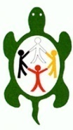
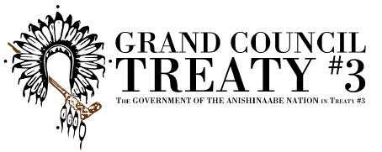

Miigwech!

