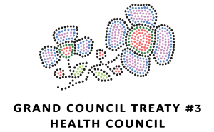
OCTOBER 15 – 16, 2019 – KENORA RECREATION CENTRE
REGISTRATION FORM (DEADLINE OCTOBER 4TH, 2019)
NAME: | COMMUNITY:
DIETARY/ALLERGIES:

INFORMATION:

2 DAY INTERACTIVE WORKSHOP THAT TEACHES PARTICIPANTS TO RECOGNIZE WHEN SOMEONE MAY HAVE THOUGHTS OF SUICIDE AND WORK WITH THEM TO CREATE A PLACE THAT WILL SUPPORT THEIR IMMEDIATE SAFETY

PROVIDED:

LIGHT REFRESHMENTS & SNACKS, LUNCH, ALL WORKSHOP MATERIALS (PARTICIPANT PACKAGE INCLUDES WORKBOOK, STICKERS, WALLET CARD, RESOURCE SHEET AND CERTIFICATE)

CONTACT: PLEASE EMAIL REGISTRATION FORM TO TASSANEE WEESE

GCT3 EMAIL: MHPA@TREATY3.CA

FOR MORE INFORMATION PLEASE CONTACT 807-464-6517 OR EMAIL MHPA@TREATY3.CA

