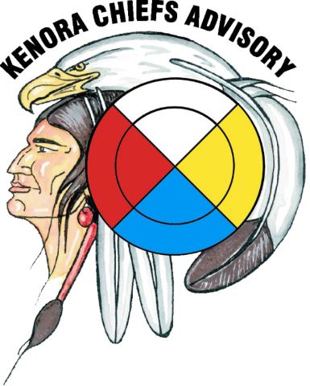
HOW TO ISSUE HYDRO REBATES TO OW CLIENTS TRAINING SESSION

Invitation to the Social Service Administrators in the Treaty #3 Area
When: Friday, March 29th, 2019
Where: Canad Inns – Club Regent Hotel
1415 Regent Avenue West
Winnipeg, Manitoba
(204) 667 5560

Registration Deadline Friday, March 8th, 2019
Agenda to be forwarded upon registration
_______________________________________________________________________
Accommodations will be provided for one (1) participant per community.
FOR MORE INFORMATION OR TO REGISTER PLEASE CONTACT:
Email: cheyenna.white@kenorachiefs.ca | Phone: (807) 467-8144 | Fax: (807) 467-2656
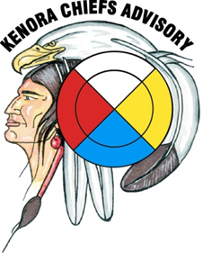
How to Issue Hydro Rebates to OW Clients
Training Session
Canad Inns Club Regent - March 29th, 2019
INFORMATION: One (1) participant per community invited to attend.

REGISTRATION: DEADLINE MARCH 8th, 2019
Name:

Community:

Email or
contact #

Position

Dietary / Allergies:

Circle Y/N if room is required. Y N | Accommodations at the Canad Inns – Club Regent
Check In Date | Check Out Date

Accommodations to be provided for one (1) member per community only. It is possible that mileage could be compensated after the session.
Any questions or concerns? Please call Kenora Chiefs Advisory at 1-807-467-8144.
Or by email: Cheyenna White @ cheyenna.white@kenorachiefs.ca

