IHWS COMMUNITY WORKERS: ELDER ABUSE TRAINING
MARCH 4TH & 5TH, 2019 ~ BEST WESTERN PLUS WINNIPEG AIRPORT HOTEL
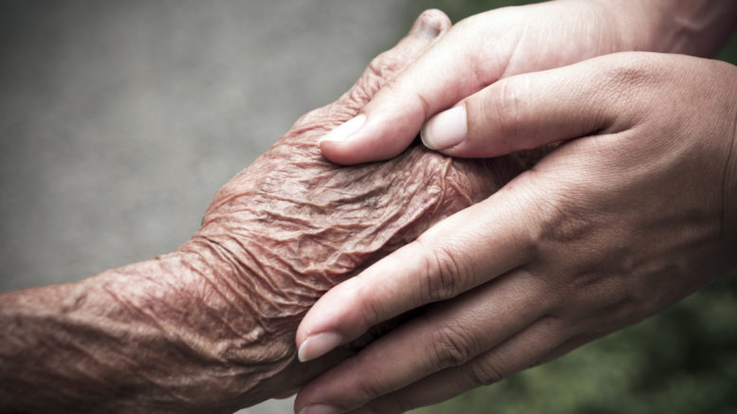

REGISTRATION FORM
Register by 1:00 p.m. Friday February 25th, 2019
Location: Best Western Plus Winnipeg Airport Hotel
Training for IHWS Community workers.
** limited seats** others will be put on waiting list.

NAME
COMMUNITY:
Job Title

IHWS worker/partner? | ⃝ YES ⃝ NO
Email
Dietary, Allergies
Information | - Rooms provided, check in date: March 3rd  - Breakfast, lunch, morning & afternoon snacks provided March 4th & 5th.  - Travel reimbursement to IHWS partners/worker/ FN communities.

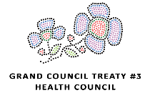
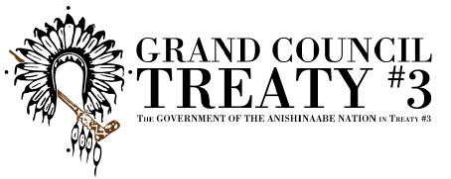
Questions? Contact GCT3 health dept: 1-807-548-4214

Grand Council Treaty #3 | P.O. Box 1720, Kenora, ON, P9N 3X7 | www.gct3.ca
TEL: (807)548–4214 | TOLL FREE: 1-800-665-3384 | FAX: (807) 548 5041

