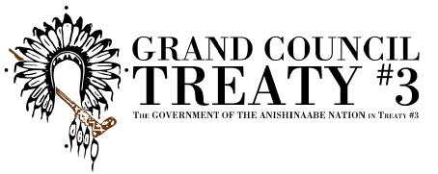

Income Assistance & Engagement Session Registration
Kenora Clarion November 14th - November 15th, 2018

INFORMATION: Three (3) participants per community invited to attend. 1 social services administrator, 1 participating OW/ODSP client, & FN Council member (social portfolio).
REGISTRATION: DEADLINE NOVEMBER 1^{ST.}
Name:

Community:

Email or
contact #

Check one | Social Services Admin ⃝ OW/ODSP client ⃝ Social Portfolio Councillor ⃝
Dietary / Allergies:

Circle Y/N if room is required. Y N Accommodations at the Clarion.

Questions? Call GCT3 office: TF: 1-800-665-3384 or 1-807-548-4214 for health dept.
Email: health.assistant@treaty3.ca, mentor.assistant@treaty3.ca
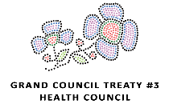
Gct3 will provide accommodations & lunch both days, mileage reimbursed to communities.

Grand Council Treaty #3 | P.O. Box 1720, Kenora, ON, P9N 3X7 | www.gct3.ca
TEL: (807)548–4214 | TOLL FREE: 1-800-665-3384 | FAX: (807) 548 5041

