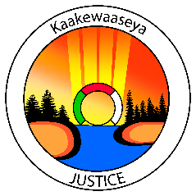

**KAAKEWAASEYA JUSTICE SERVICES PRESENTS**

**REVITALIZATION OF INDIGENOUS SYSTEMS**

**SEVEN GENERATIONS EDUCATION INSTITUTE - KENORA, ON**

**MARCH 6, 2018**

**REGISTRATION FORM**

|  |  |  |  |
| --- | --- | --- | --- |
| **PARTICIPANT INFORAMTION** | | | |
| **Name:** |  | | |
| **Community:** |  | | |
| **Organization/Title:** |  | | |
| **Phone:** |  | | |
| **Email:** |  | | |
| **Special Dietary/allergies:** |  | | |
| **EMERGENCY CONTACT** | | | |
| **Name:** |  | | |
| **Phone:** |  | | |
| **Relationship:** |  | | |
| **ADDITIONAL INFORMATION** | | | |
| **Grand Council Treaty #3 will provide travel and accommodation for the Chief or designated community member and (1) Elder per community. Elder must be identified by Chief and Council.**  **Please Note:**   * If you need to cancel accommodations, **please contact the hotel directly 24 hours before check-in tim**e, otherwise your community will be responsible for reimbursement to GCT3 for no shows. | | | |
| **Do you require a hotel room?** | | ❑ **Yes** | ❑ **No** |

REGISTRATION DEADLINE:

Please contact our office in advance to confirm your registration. Return the completed registration form and release form to the address/fax number below by**:**

**FEBRUARY 28, 2018**

**Please Send Completed Forms to:**

Alicia McLeod, Justice Projects Assistant | Email: [alicia.mcleod@treaty3.ca](mailto:alicia.mcleod@treaty3.ca)

Phone: 807.548.4214 ext.239 | Fax: 807.548.5054