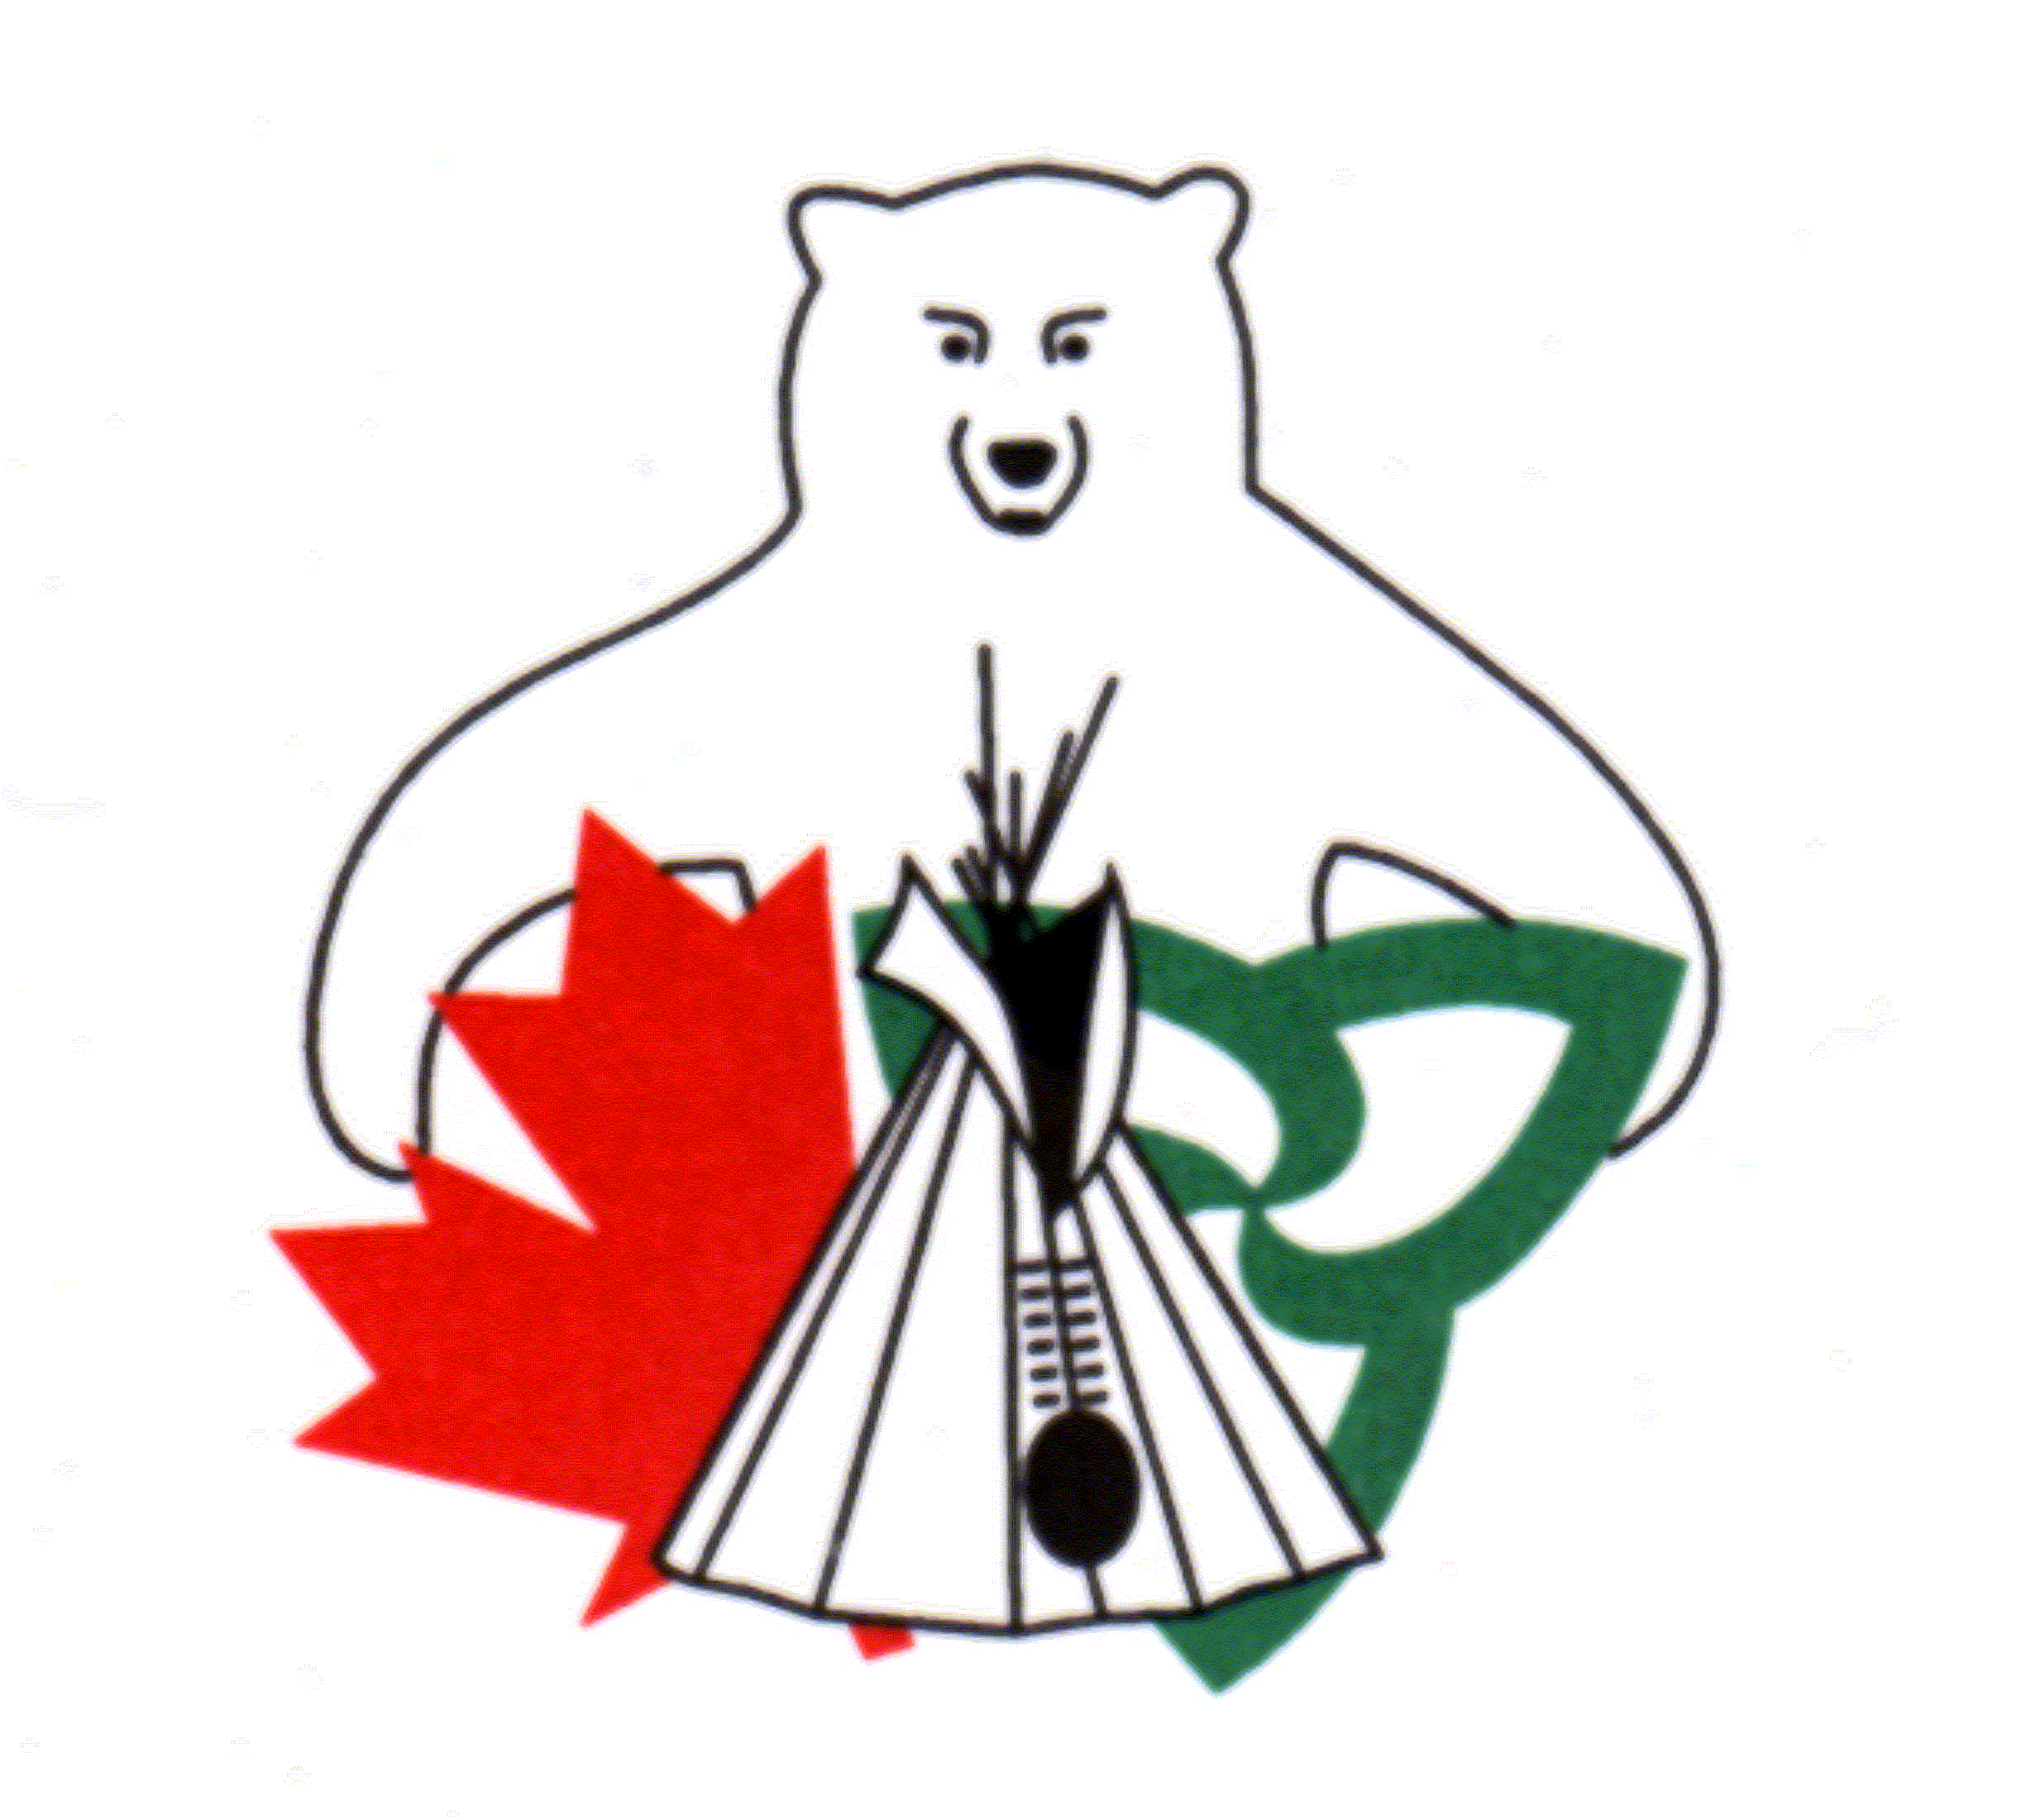
Canada Ontario Resource Development Agreement
2018-2019 Guide Book

Project approval for 2018-2019 and beyond is subject to confirmation of funding. Proposals will be received and reviewed in anticipation of funding availability. However, please note that if funding is not available no projects will be approved.

The Canada Ontario Resource Development Agreement (CORDA) is an agreement between Canada, Ontario and First Nations’ members in Ontario. CORDA is funded by Indigenous and Northern Affairs Canada and the Ontario Ministry of Natural Resources and Forestry.

The Agreement promotes resource and economic development initiatives of First Nations’ members by providing financial assistance to develop and utilize renewable natural resources.

Who is Eligible?
For all projects, First Nations, their members and organizations, and Treaty organizations in Ontario are eligible to apply. (First Nations and First Nations’ Governments have the same meaning as Indian Bands or their successors under federal legislation and any new Canadian Constitutional arrangements).

Applicants must be residents of Ontario.

Funding Level
The maximum funding amount for projects approved under the CORDA Program is $35,000.00.

Eligible Projects
To be eligible for consideration, the application shall meet and demonstrate the following criteria:

- The project must promote natural resource development, management, harvesting and conservation in Ontario. Projects must involve one or more of the following:

- Commercial Fishing, including all aspects of sustained yield production and quality control
- Fur Trapping, including all aspects of trap line management and pelt quality control
- Forestry, harvesting, maintenance, renewal and access
- Non-timber forest products including wild rice, blueberries, wild traditional crops and medicinal plants
- Deer, bear, barren-ground caribou and moose hide utilization
- Sports fishing and hunting, including assistance to guides and outfitters
- Fishing and hunting for domestic use
- Commercial recreation related to the development of renewable natural resources including ecotourism, hunting camps, guiding, skiing and snowmobile trails
- Processing and marketing of products derived from natural resource development, management and harvesting
- Environmental projects relating to resource development
- Natural resource planning such as those projects related to natural heritage or addressing invasive species

- Any previous projects by the applicant must be in good standing.

Eligible Expenditures
Expenditures eligible for funding under this program include but are not limited to:
- Equipment (e.g. purchase or rental of equipment)
- Materials (e.g. building materials or purchase of facilities)
- Labour (excludes labour for self)
- Transportation (e.g. transportation of personnel, supplies and equipment)
- Other (e.g. technical advice and assistance, acquisition of data base information, promotion and advertising of commercial ventures)

Ineligible Expenditures
Expenditures under this program do not include:
- pleasure crafts and recreational vehicles
- personal or domestic expenditures
- project administration costs
- labour costs for the applicant

Multiple applications for the same project activity (project splitting) to maximize funding are not eligible

Supporting Documents
For all applications, the applicant must provide details outlining the resource management and economic viability of the proposed project, including:
- background information on the objectives, project description, resources utilized etc.
- short- and long-term economic, resource and cultural benefits
- agencies providing financial or advisory services

All applications must include the following supporting documents:
- supplier quotes for all proposed expenditures
- a demonstration of community support by either a letter or Band Council Resolution, as appropriate

Applicants may also wish to provide additional documents to support the application. These documents may include, but are not limited to:
- a letter of support from an appropriate administering agency (e.g. the Ministry of Natural Resources and Forestry)
- maps
- photographs
- licenses (e.g. trapping/ fishing)
- Community Economic Development Plan, feasibility study, or Business Plan
- cultural and traditional practices sustained through the project (if applicable)

Applications that do not include the required supporting documentation at the time of submission will not be reviewed.

Environmental Regulations
Applicants are responsible to demonstrate, in writing, that projects are environmentally sound and meet all applicable environmental guidelines and regulations.

Application Deadline
The complete application package, including a complete and signed application form and all required supporting documents, must be received by the CORDA Office by Monday, October 30, 2017 at 11:59 p.m. Eastern Daylight Time.

Applications received after this date will not be considered.

Approval Process
Complete applications received by the deadline will be reviewed and ranked based on selection criteria established by the CORDA Committee. Applications are reviewed for administrative criteria, including strength of the project plan, economic benefits, regional need, and benefits to traditional knowledge/cultural values. The CORDA Committee reviews each project proposal to determine the level of funding that will be granted to each project. Projects may, at times, be approved for funding at an amount less than requested.

Where applicable, appropriate permits and approvals are required prior to the start of the project.

Approval letters are sent to successful applicants, along with a copy of the Conditions of Receipt of a CORDA Grant form, and a copy of the Interim/Final Report template.

Funding Distribution and Reporting Requirements
For approved projects, the disbursement schedule will be based as follows:
- First Installment: 50% of approved funding will be released upon receipt of a signed Condition of Receipt of a CORDA Grant agreement.
- Second Installment: 25% of approved funding will be released after projects submit the Interim Report and it is approved; the receipts and invoices must demonstrate expenditure of the first installment (50% of approved project funding). The Interim Report must be submitted no later than November 23, 2018.
- Third Installment: 25% of funding will be released after projects submit the Final Report and it is approved. The remaining amount of funding released is based on all project expenditures demonstrated through receipts/invoices.
- No funding will be provided to an applicant for any related expenses incurred prior to receiving written approval for a project.
- Applicants, at times, may not spend all of the funding approved through CORDA. In these cases, applicants will only receive funding in the amount supported through invoices/receipts provided with the Final Report.
- Funding may not occur until after July 1, 2018.
- All funds must be spent by February 22, 2019.
- The Final Report is due to the CORDA Office March 1, 2019.
- Any unused funds must be returned to the organization that issued the funds by March 15, 2019.

How to Apply
The enclosed application form, in its original form, must be completed in full, signed and submitted with supporting documents by October 30, 2017 to:

CORDA Office
123 Paudash Street
Hiawatha, ON K9J 0E6
Facsimile: 705-295-7144
E-mail: corda@nexicom.net

Applicants are encouraged to apply by e-mail.

Incomplete, unsigned or late applications will not be considered. Submission of an application does not guarantee approval for funding.

Contact Information
For more information contact:

Jill Stevens, Secretariat
CORDA Office
123 Paudash Street
Hiawatha, ON K9J 0E6
Telephone: 705-295-7116
Facsimile: 705-295-7144
E-mail: corda@nexicom.net

Additional copies of the application package are also available from the following:
- Ministry of Natural Resources and Forestry (MNRF) District Offices
- Indigenous and Northern Affairs Canada (INAC) Regional Office
- Grand Council Treaty #3 website at http://www.gct3.net
- Anishinabek Nation website at http://www.anishinabek.ca
- Nishnawbe Aski Nation website at http://www.nan.on.ca
- Association of Iroquois and Allied Indians website at http://www.aiai.on.ca

